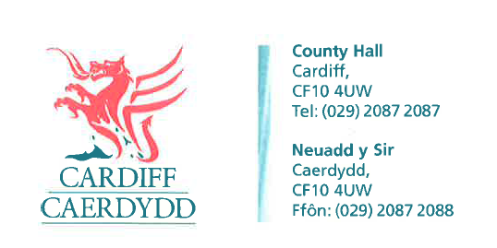
FOI Response Document
FOI10629
Thank you for your request under the Freedom of Information Act 2000 about EV Charging Point Statistics received on 12/09/2017:
- How many total EV charging points are installed in the council area.
- How many EV charging points are rapid chargers?
- How many EV charging points are fast chargers?
- How many EV charging points are slow chargers?
- What percentage of charging points are used at least once per day?
- What percentage of charging points are used at least once per week?
- What percentage of charging points are used at least once per month?
- How many charging units has Cardiff Council installed in the past 5 years?
9. How many charging units is Cardiff Council planning to install in the next 5 years?
We have considered your request and enclose the following information:
The City of Cardiff Council has not installed any EV charge points.
Information about publically available charge points can be found by using various charge point websites e.g. https://www.zap-map.com/live/
The City of Cardiff Council is currently undertaking work to commission a feasibility study for the future of EV charging in the city. This will provide information which the Council will use to take decisions about the type, model and number charging points in any future EV changing infrastructure.
If you have any queries or concerns, please do not hesitate to contact us.
Please remember to quote the reference number above in any future communications.

